MPR-Manual
- After logged in ADF/DDF account, there is a menu showing name as “MPR Dashboard”.
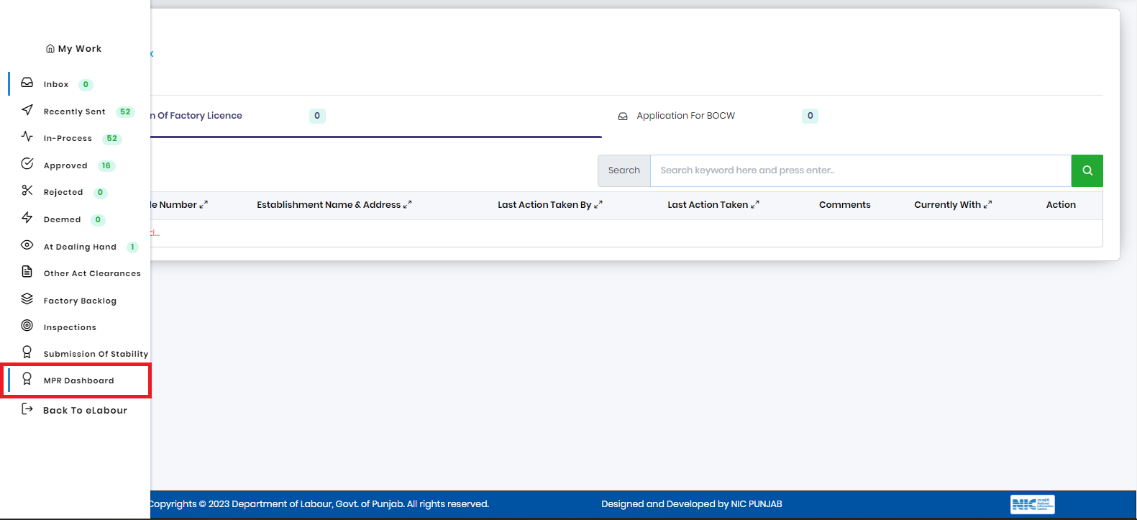
2. On clicking the menu, it will redirect to the “MPR Dashboard" This dashboard contains all the filled MPR and drafted MPR.
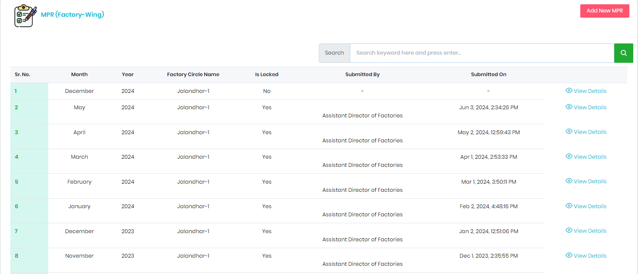

3. To fill out the MPR, there is button named as “Add New MPR” on the top right corner. On clicking the add button it will redirect to MPR form.
- In this MPR Form, the previous Month of which MPR is needed to fill and the Year is automatically fetched as showing in the snapshot.
- There are 3 buttons showing at right corner named “Save as Draft" ”Save as Lock” and “Back to Home” for taking actions to save the MPR form in draft; if the form is completely filled, then Save as Lock and Back to Home are used for going back to “MPR Dashboard.”.
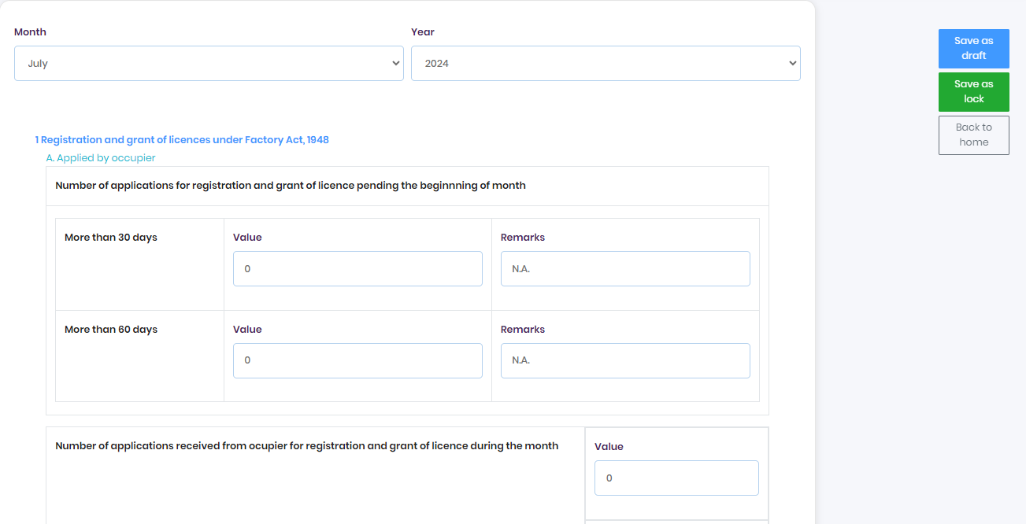
Once the MPR is drafted, it will show in the “MPR Dashboard”. Officer can edit the drafted MPR form on clicking on the edit button.
